Champion Window – Neighborhood Map Instructions
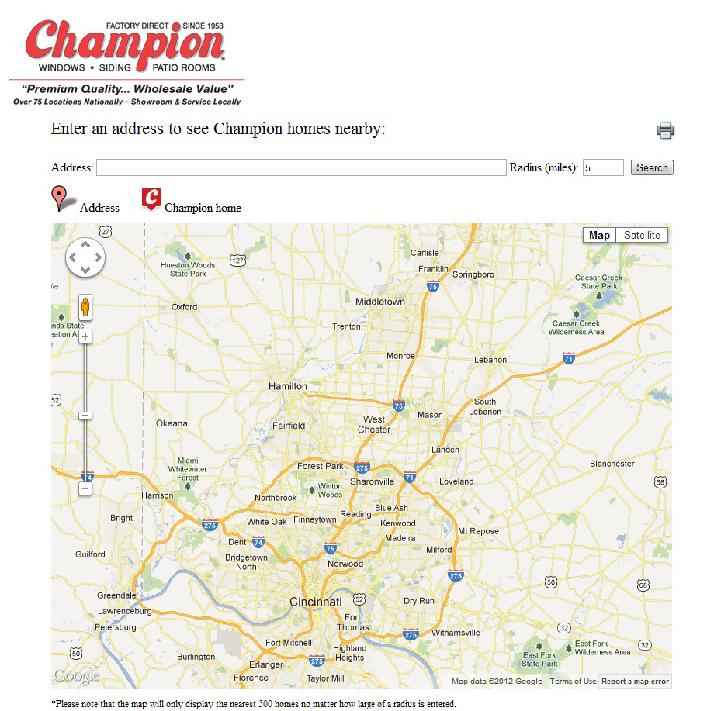
Step 1 – Search
Enter street address or neighborhood name with state abbreviation into the address box.
Hit Search.
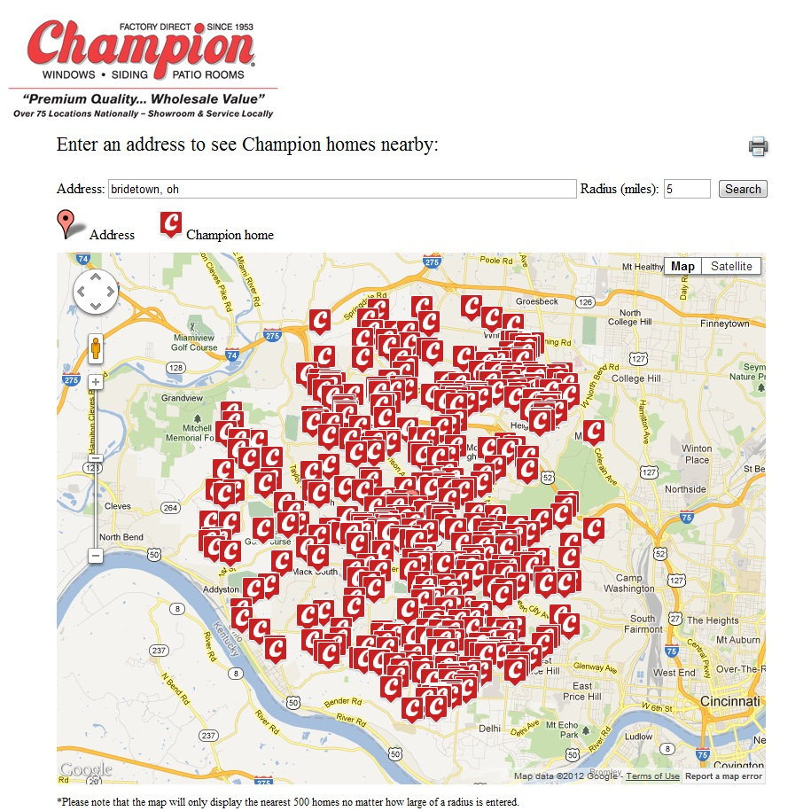
Step 2 – Zoom
Zoom to the appropriate location. Adjust the radius and search again if there are too many or too few results.

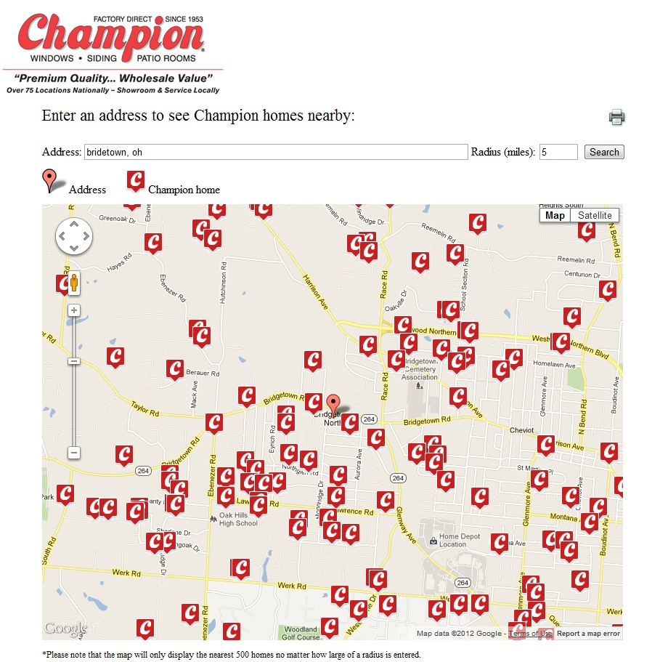
Step 3 – Print
Once you have zoomed appropriately, hit the print button to print the map and list of addresses.

